***Go To Special*** - select cells that meet specific conditions

when you first open a workbook, it is useful to get an understanding of:

* where the formulas are
* and where the input values are

from the "Go To" dialogue box i.e. "F5" 🡪 choose "Special"



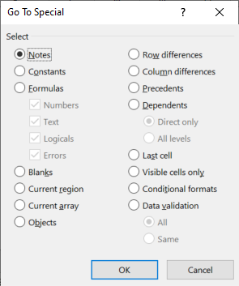

Constants

(numbers, text, logicals, errors)

Formulas

(numbers, text, logicals, errors)

ASIDE: within the dialog box:

* work your way around using the "Tab" and "Shift" + "Tab" keys
* the "Space" key to select or deselect items

*Why Useful? Can select all “hardcoded” numbers in a spreadsheet + format them ALL with one click !!!*